MODULE 3
Data Preprocessing using WEKA and Orange tool
Aim:
To perform basic data preprocessing operations such as Cleaning, Normalization, Visualization using WEKA and Orange tool.
Data Preprocessing using WEKA
Step 1:
Load Dataset Open Weka and load dataset by going to the "Preprocess" tab and clicking on "Open file." Choose the file format of dataset (e.g., ARFF, CSV) and select the dataset file from file system.
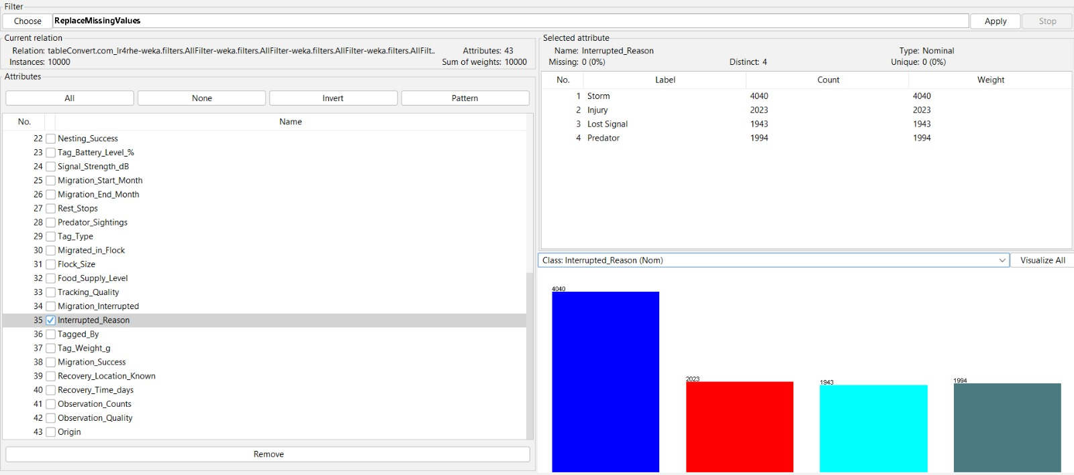
Fig 3.1 After loading Dataset

Step 2:
Explore Data Before applying any preprocessing techniques, it's essential to understand data. Use the "Visualize" option to explore statistical summaries, histograms, scatterplots, etc., to get insights into the distribution of data and identify any potential issues.

Step 3:
Apply Preprocessing Technique
Step 3.1: Data Cleaning
Handle Missing Values:
Missing values can adversely affect the performance of machine learning models. Weka offers several options for handling missing values:
Use the "ReplaceMissingValues" filter to replace missing values with the mean, median, mode, or a user-specified value.
Another option is to use more advanced techniques like imputation, which can be implemented using filters such as "SimpleImputer" or "IterativeImputer."
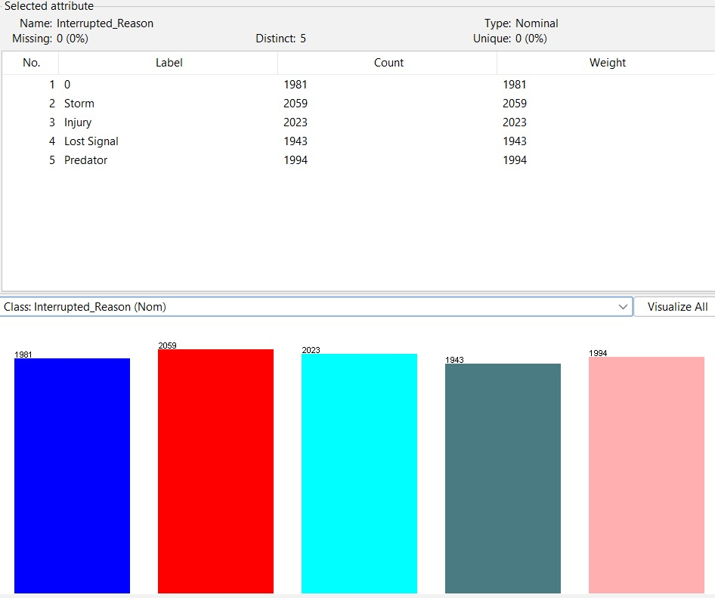
Fig 3.2 Before Handling missing values

Fig 3.3 After handling Missing values

Step 3.2:
Data Visualization Summary Statistics:
Click on the "Preprocess" tab and then select the "Open file" button to load dataset. Once loaded, summary statistics can be viewed by clicking on the "Stats" button. This will display statistics such as mean, median, standard deviation, minimum, maximum, etc., for each numeric attribute in dataset.
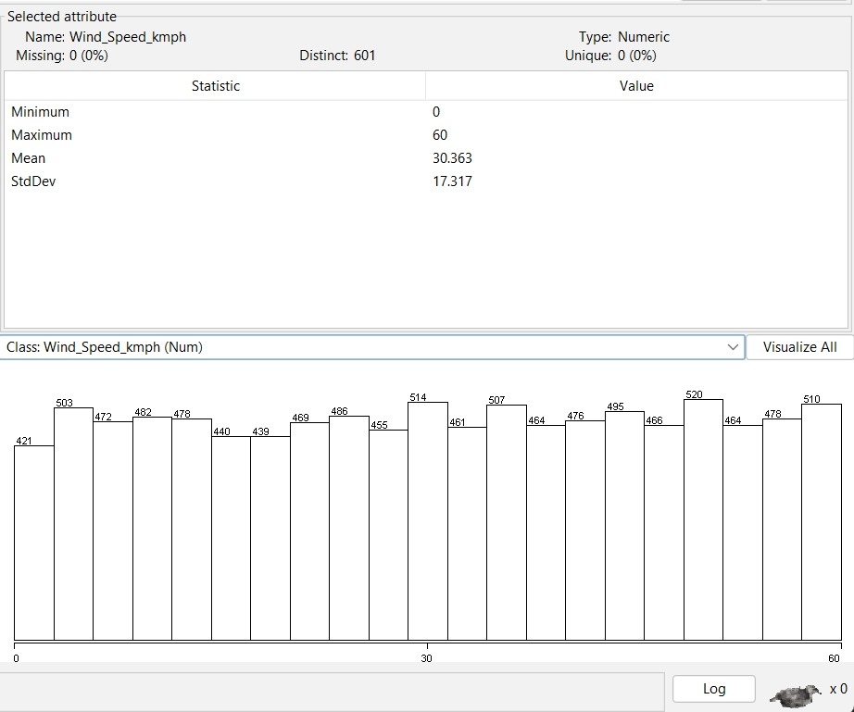
Fig 3.4 Summary Statistics for the attribute wind_speed_kmph

Histograms:
To view histograms of numeric attributes, click on the attribute name in the "Attributes" panel to select it. Then, click on the "Histogram" button to display the histogram of the selected attribute. This allows to visualize the distribution of values for that attribute.

Fig 3.5 Histogram for Class Wind_speed_kmph
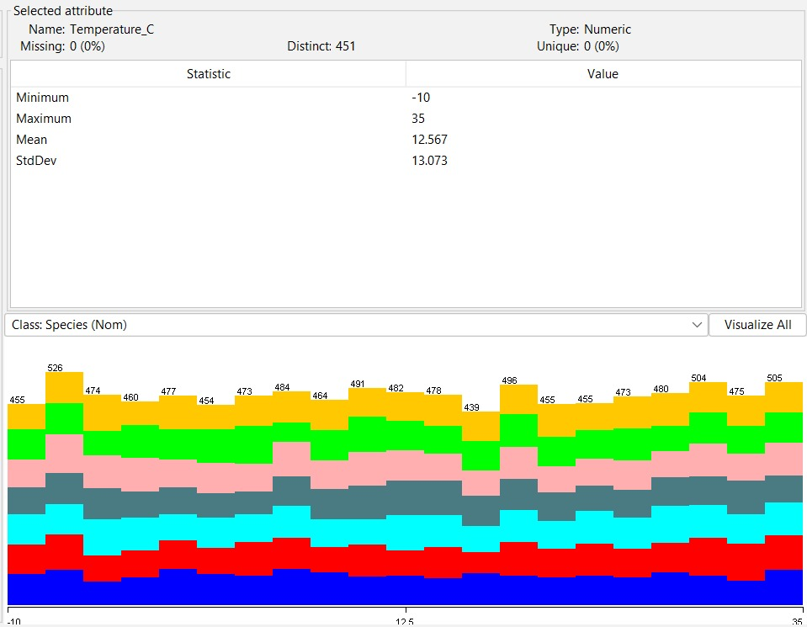
Fig 3.6 Colored Histogram for the species column
Scatterplots:
Scatterplots are useful for visualizing relationships between pairs of numeric attributes. To create a scatterplot, select two numeric attributes by clicking on their names in the "Attributes" panel. Then, click on the "Visualize" button to display the scatterplot of the selected attributes. This allows to visualize how the values of one attribute vary with respect to another.
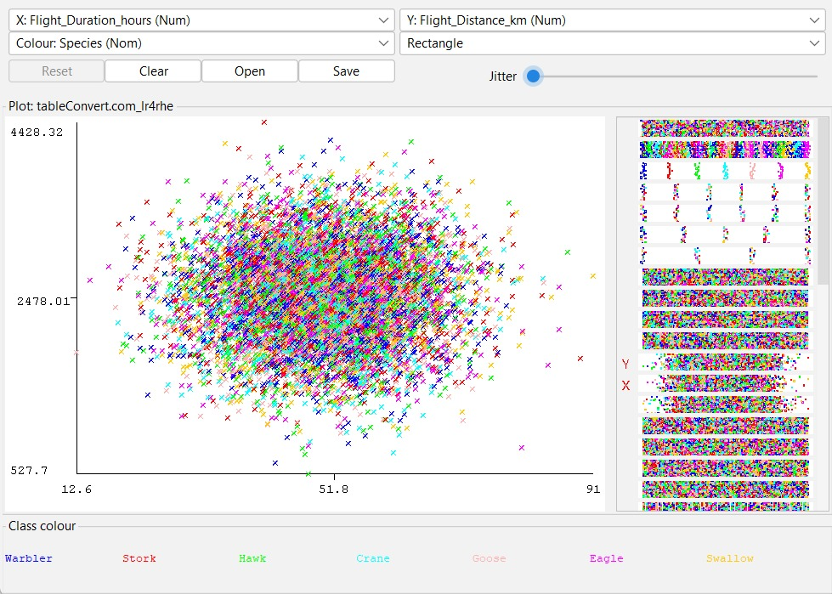
Fig 3.7 Scatterplot betwwn Flight_Duration_hours and Flight _Distance_km and color denotes the species

Bar Plot:
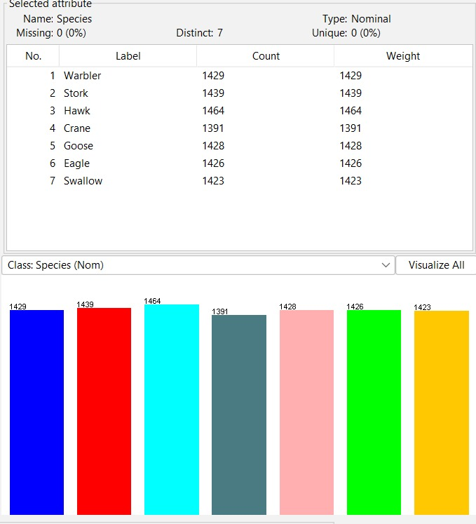
Fig 3.8 Bar plot for the Column Species

Step 4:
Save Preprocessed Data After cleaning / normalization / visualization, save the preprocessed dataset by clicking on the "Save" button.

Data Preprocessing using Orange
Step 1:
Load Dataset Launch Orange and load dataset by either dragging and dropping the file into the Orange interface or using the "File" menu to open it.
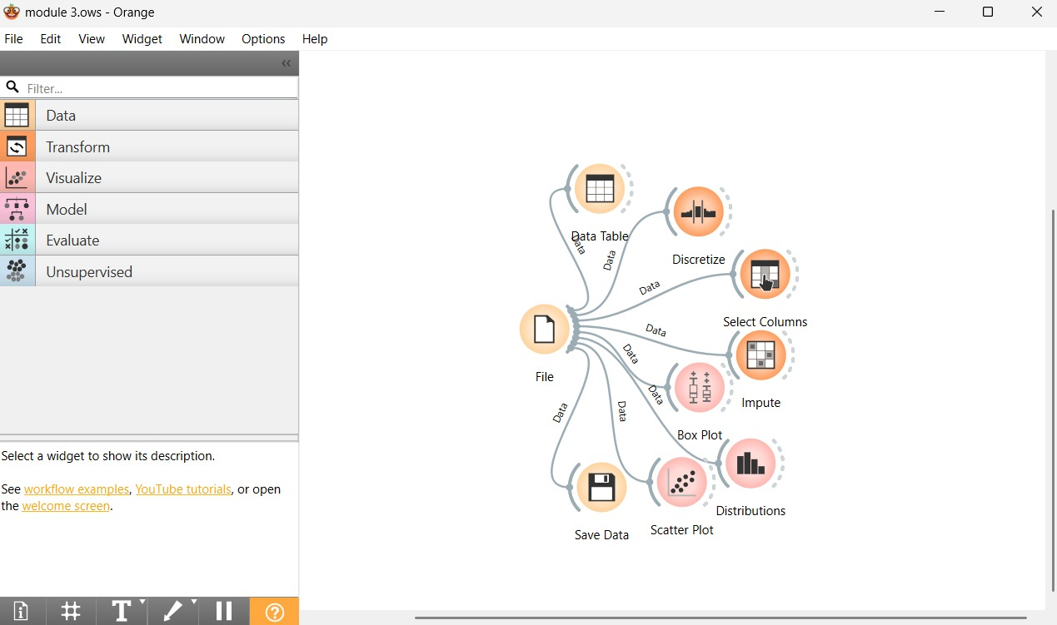
Fig 3.9 Loading orange

Step 2:
Explore Data Once dataset is loaded, use the "Data Table" widget to visualize and explore the contents of dataset.
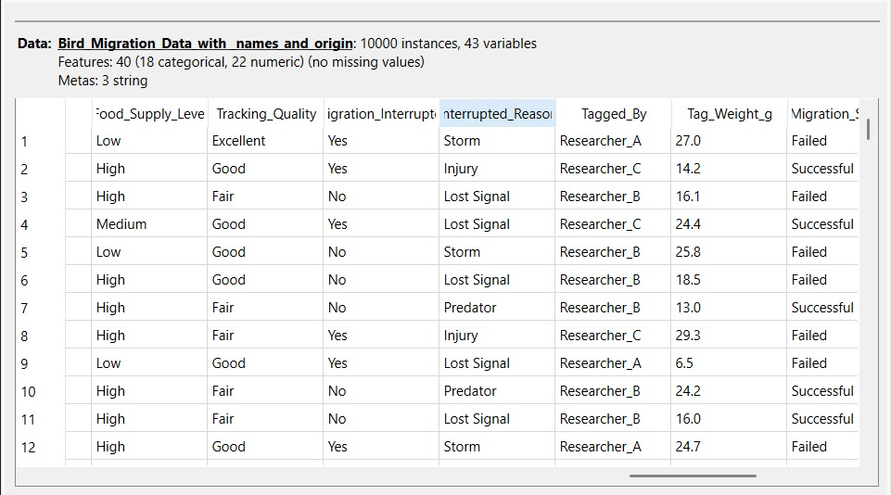
Fig 3.10 Data table for the dataset
Step 3:
Handle Missing Values
If dataset contains missing values, handle them using the "Impute" widget. This widget provides options for imputing missing values using various techniques such as mean, median, or most frequent value imputation.
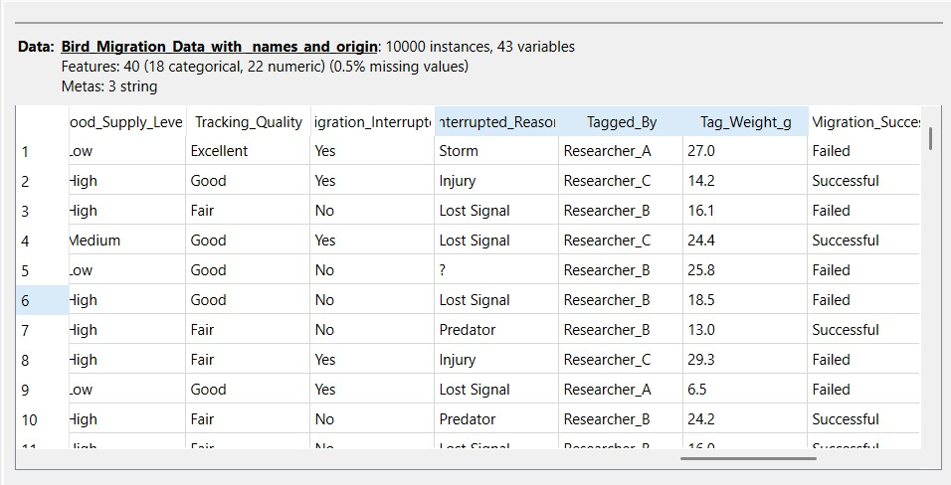
Fig 3.11 Dataset with missing values

Fig 3.12 Dataset after imputation

Step 4:
Discretize Data
If dataset contains continuous numeric attributes that need to be discretized, use the "Discretize" widget. This widget allows to discretize numeric attributes into bins based on various methods such as equal frequency or equal width.
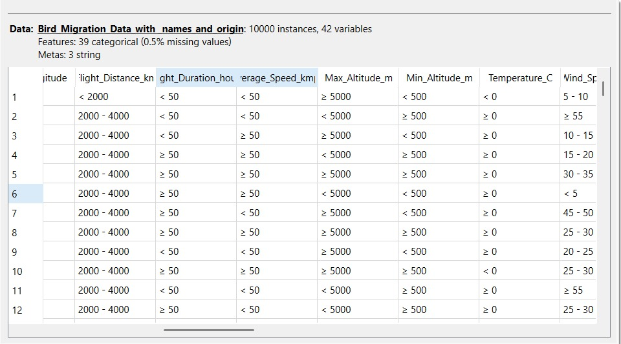
Fig 3.13 Dataset after discretization

Step 5:
Filter Data
Orange provides various filtering options to preprocess data. Use the "Select Columns" widget to remove or retain specific attributes, the "Select Rows" widget to filter instances based on specific criteria, and the "Select Domain" widget to filter instances based on their domain values.
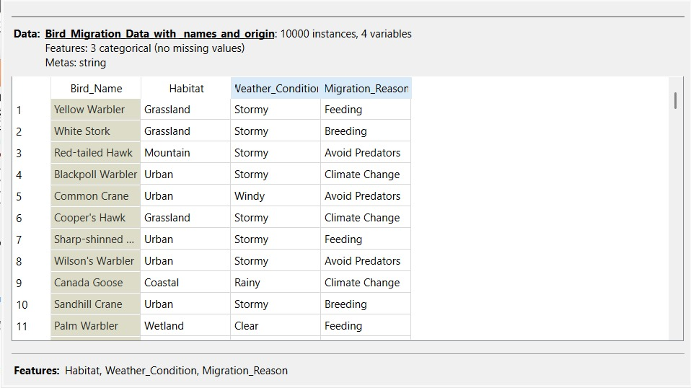
Fig 3.14 Dataset After Filtering

Visualization using Orange
Step 6:
Box Plot:
Boxplots provide a visual summary of the distribution of a numeric attribute grouped by a categorical attribute. This allows to visualize the distribution of the numeric attribute across different categories of the categorical attribute.
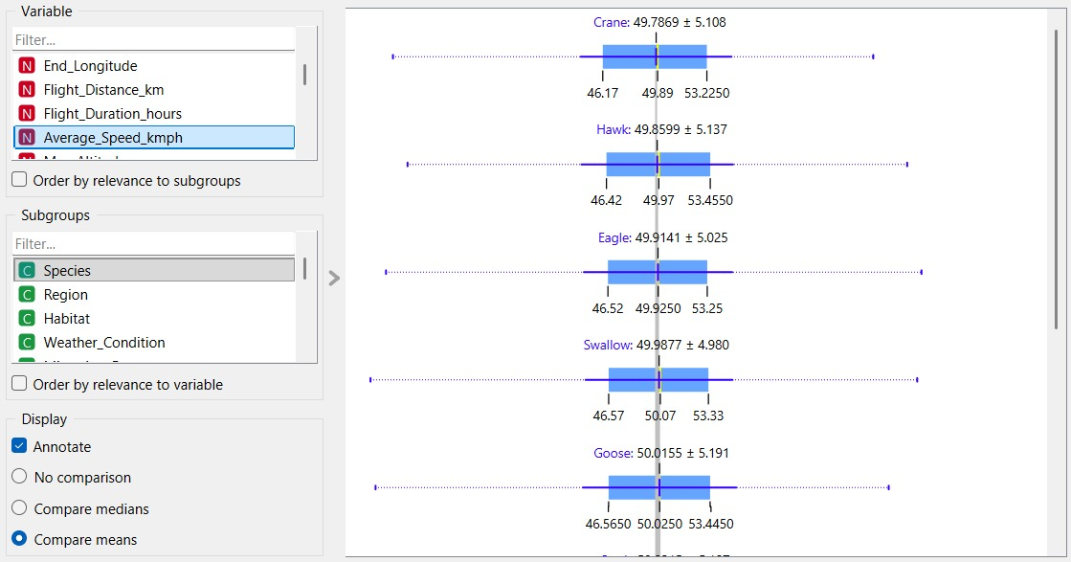
Fig 3.15 Box plot between Average speed and species

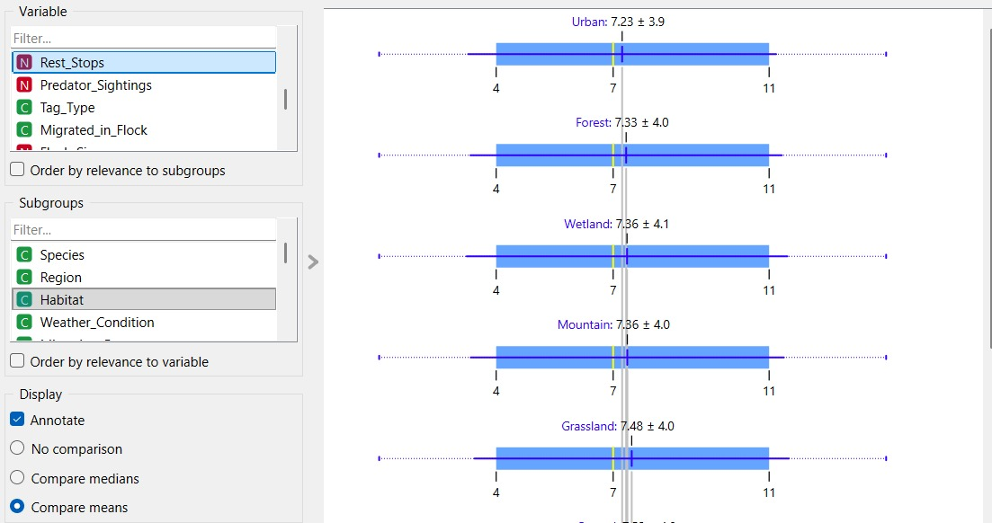
Fig 3.16 Box plot between Rest stops and habitat
Bar plot:
A bar plot (or bar chart) is a visualization tool that uses rectangular bars to represent and compare numerical values across different categorical groups.
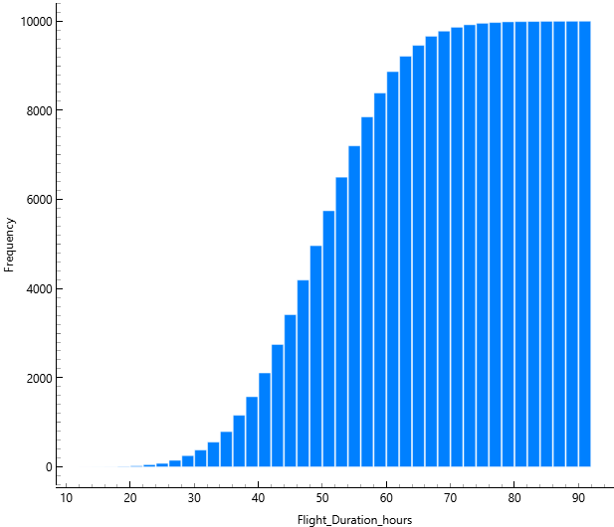
Fig 3.17 Bar plot for flight_duration_hours

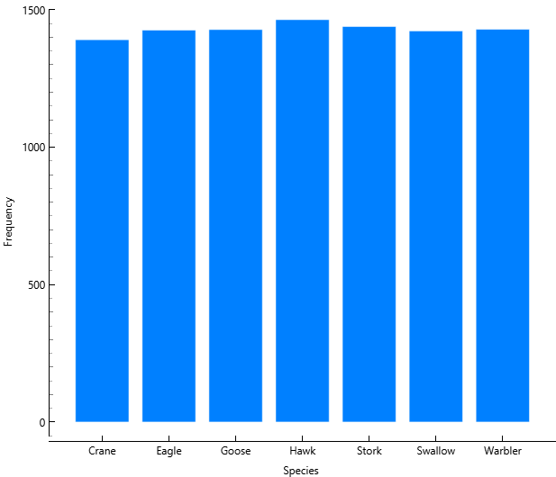
Fig 3.18 Bar plot for Species
Scatter plots:
Scatterplots are useful for visualizing relationships between pairs of numeric attributes

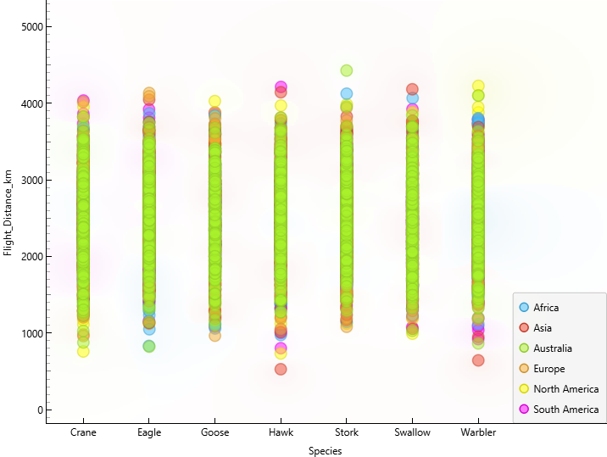
Fig 3.19 Scatter plot between flight distance and species
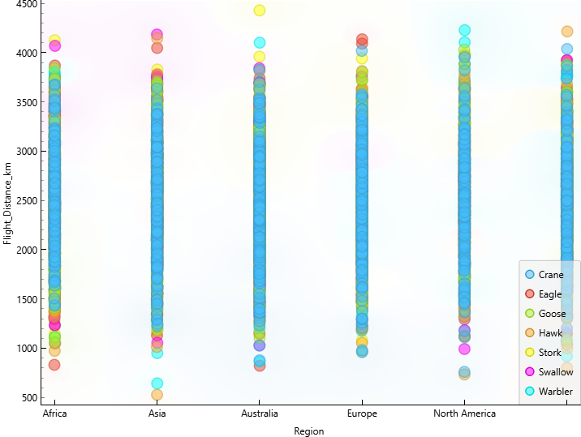
Fig 3.20 Scatter plot between flight distance and Region

Step 7: Save Preprocessed Data
Once completed the preprocessing steps, save the preprocessed dataset using the "Save Data" widget. This widget allows to specify the file format and location for saving the preprocessed data.
Step 8: Evaluate Preprocessed Data
Before proceeding with further analysis or modeling, it's important to evaluate the preprocessed data to ensure that it meets requirements. Use the "Data Table" widget or other visualization tools in Orange to inspect the preprocessed data and verify that the preprocessing steps were applied correctly.

Problem Statement:
Statement 1:
The objective of this exercise is to preprocess the Bird Migration dataset by handling missing values, removing inconsistencies, and transforming the data into a suitable format. Further, data visualization techniques are applied to analyze migration patterns, environmental impact, habitat behavior, and recovery trends to support better understanding and decision-making.

Result:
Thus, the basic data preprocessing operations such as Cleaning, Normalization, Visualization was performed using WEKA and Orange tool.

